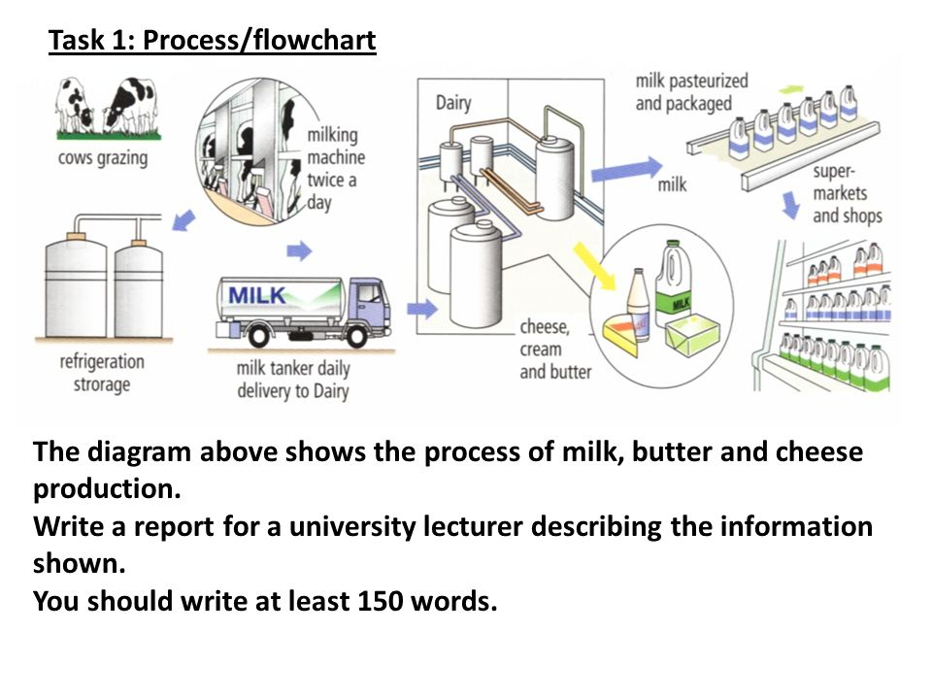

The diagram highlights the process by which milk, butter and cheese are produced in modern life. Overall, the key steps of milk production are collecting, storing, processing and selling.

The first step of this complex process is that twice a day, after grazing, cows are brought in the cowshed where special machine adjust milk gathering. Once the liquid has been collected, it is then dispatched into the refrigeration storage. At this point, the milk is loaded into a daily tanker which then delivers it to the Dairy. When cheese, cream and butter have been produced, the milk is gone through pasteurization and packaging processes in order to prevent it from spoiling. The last step is that the milk is traveled to the supermarket and shop shelves, where people can buy it.

To sum it up, the milk that most of us drink every day has passed along the journey to become a pleasant drink on our table.